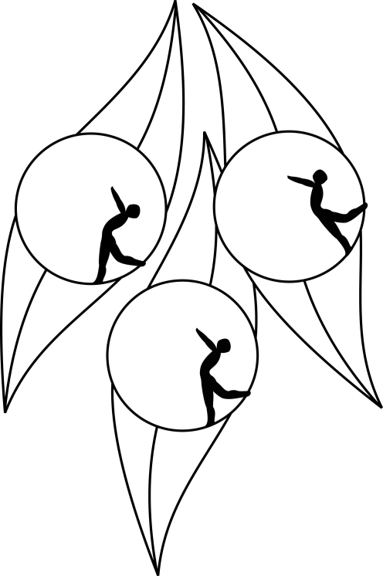
SOUTH AUSTRALIAN ICE SKATING ASSOCIATION Inc.

RESULTS

TEST SESSION

8 November 2009
Ice Arena, Thebarton

Congratulations to the following skaters

Elementary 2 Figure Pattern:
Madeline Swan

Elementary 1:
Alyce Skeates

Preliminary
Samantha Kelly

